**Travel Blog Project Documentation**

**Objective:**

The primary objective of this project is to create a personal travel blog that is hosted on IBM Cloud Static Web Apps. The blog will serve as a platform for the author to share their travel adventures, tips, and captivating photos with the world. By using IBM Cloud Static Web Apps, the goal is to make it simple and convenient to update the blog and document journeys, inspiring others to explore the beauty of the world and create unforgettable memories.

**Design Thinking Process:**

* **Ideation**

The project originated from the idea of creating a personal travel blog to share the author's travel experiences and inspire others. The key considerations during this phase included:

- The purpose of the blog - to share travel experiences, advice, and photos.

- The choice of IBM Cloud Static Web Apps as a hosting solution due to its ease of use, scalability, and reliability.

* **Planning**

In the planning phase, the project's objectives and features were defined, and the content structure was outlined. The key planning activities included:

- Defining the project's objectives and goals.

- Identifying the features and functionalities required for the blog.

- Planning the technical stack and tools that will be needed for development.

- Determining the branding, including the blog's name, logo, and the general look and feel.

* **Design**

The design phase involved creating wireframes and design mockups for the website's layout and user interface. This phase also included:

- Selecting a color scheme and fonts that reflect the travel theme.

- Designing the blog's logo.

- Choosing imagery and photographs to be used in blog posts.

* **Development**

In the development phase, the project was built from the ground up. The main development activities included:

- Setting up the project structure with directories for HTML, CSS, and assets.

- Creating the website using HTML, CSS, and JavaScript.

- Implementing a content management system (CMS) to allow for easy content updates.

- Integrating with IBM Cloud Static Web Apps for hosting and deployment.

**Development Phases:**

The development process was divided into several phases to ensure a systematic and organized approach:

**Phase 1: Website Setup**

- Created the basic website structure with placeholders for different sections.

- Set up the project on IBM Cloud Static Web Apps to establish the hosting environment.

**Phase 2: Content Creation**

- Added blog posts, each featuring a travel adventure, tips, and captivating photos.

- Developed a custom content management system (CMS) that allows for easy content updates and new blog post creation.

**Phase 3: User Interface Design**

- Styled the website for an appealing user interface.

- Ensured that the site is responsive to accommodate various screen sizes.

- Added navigation menus, social sharing buttons, and search functionality for a user-friendly experience.

**Phase 4: Deployment and Testing**

- Deployed the website to IBM Cloud Static Web Apps for production use.

- Conducted extensive testing to ensure proper functionality, performance, and responsiveness on various devices and browsers.

**Website Structure:**

The website's structure is designed to provide visitors with a seamless browsing experience. The main sections of the website include:

**1. Home Page**

- Introduction to the blog ,about and featured blog posts.

**2. Blog**

- A list of blog posts with titles, summaries, and images.

- Search functionality to help users find specific blog posts.

**3. Individual Blog Post Pages**

- Detailed travel adventures with tips and photos.

- Comment section for reader interaction.

**4. Destination**

-it contains many place information, photos

- the places like kerala,goa and mysore etc..

**5.gallery**

-it contains all places pictures

- the pictures are very wonderful

**6. Contact**

- A contact form and contact information for readers to reach out.

**Technical Implementation:**

Frontend: HTML, CSS, JavaScript

Content Management System (CMS): Custom-built for easy content updates

Hosting: IBM Cloud Static Web Apps for scalability and reliability

Version Control: Git and GitHub for version management and collaboration

**Screenshots:**

**Signin page:**

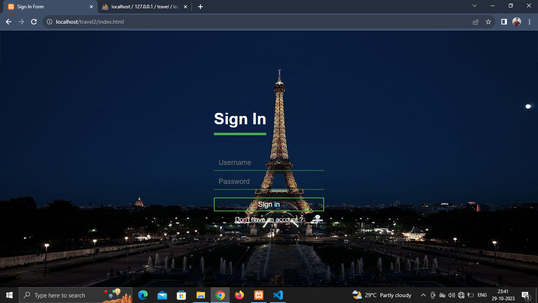

**Signup page:**

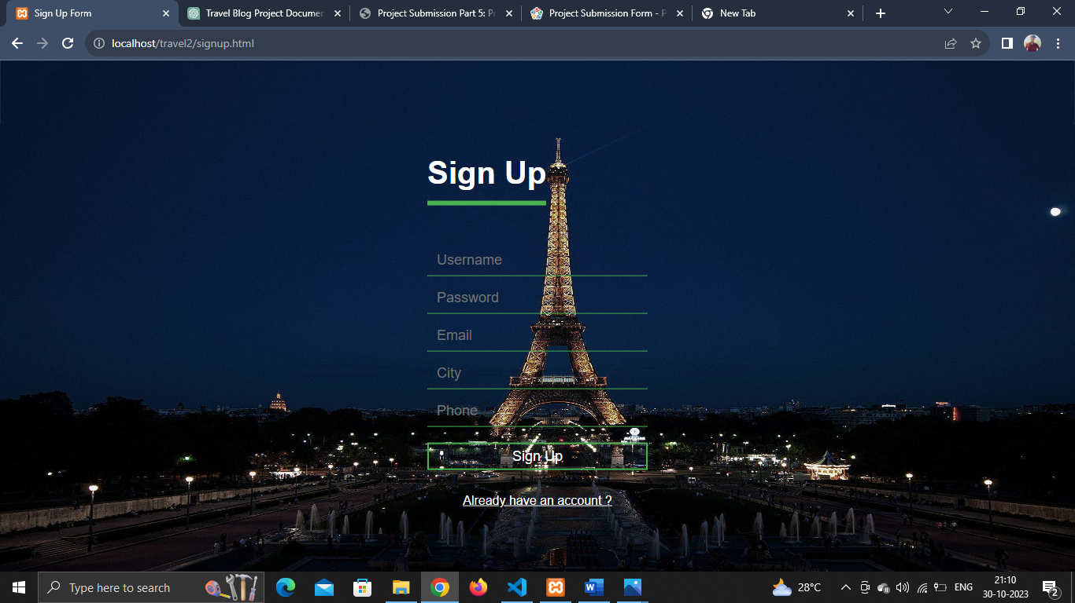

**Home Page:**

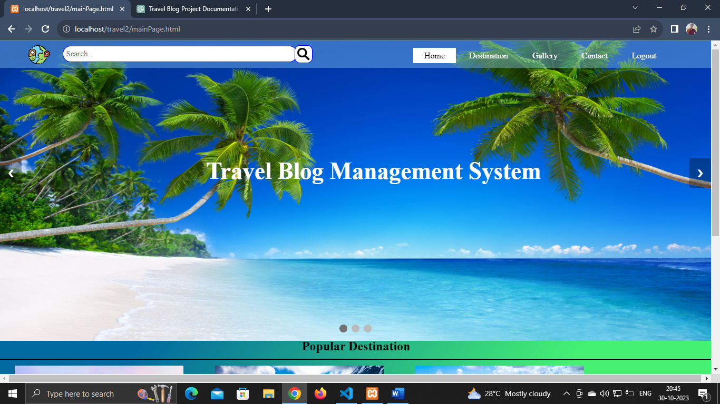

**Admin page:**

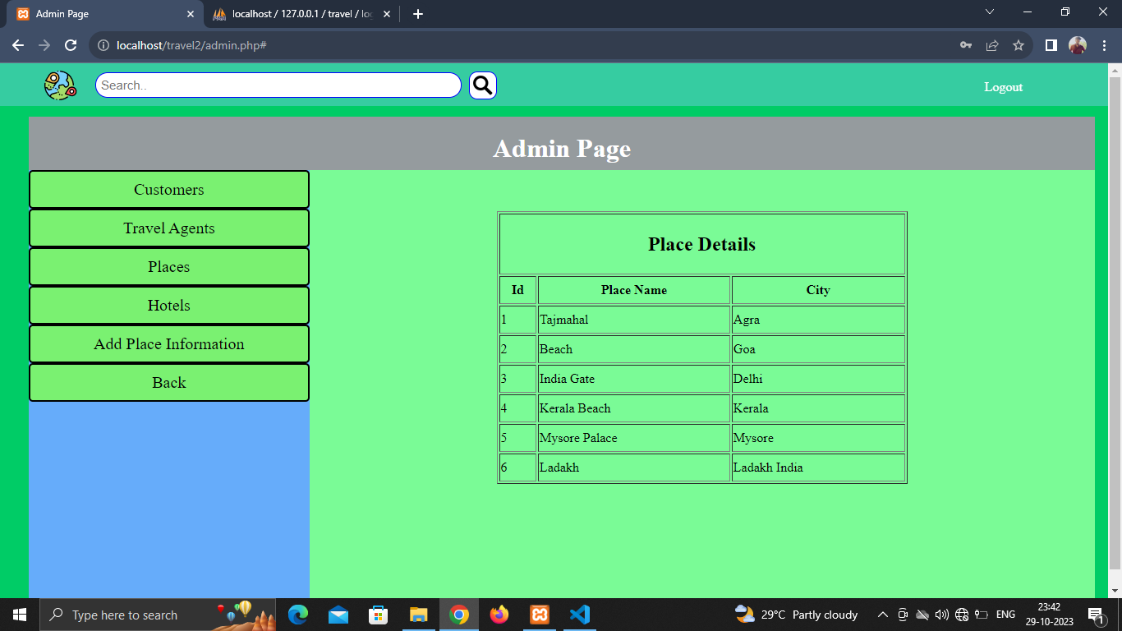

**Destination page:**

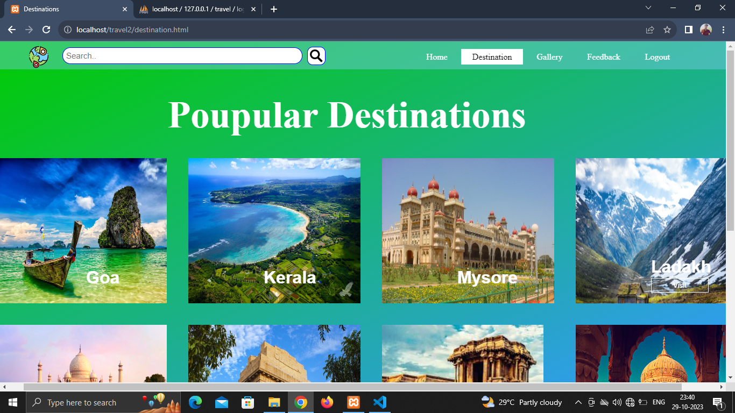

**Gallery page:**

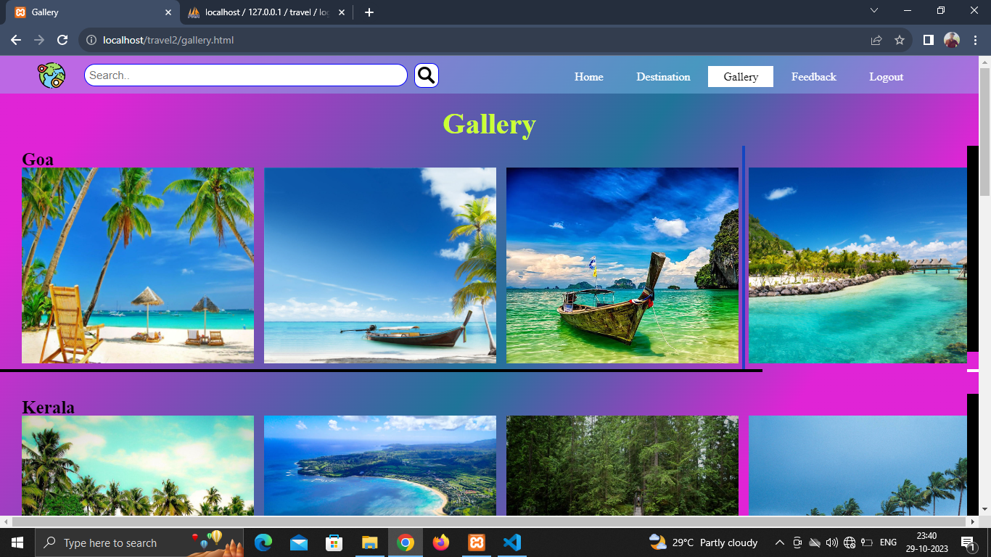

**Blog Page:**

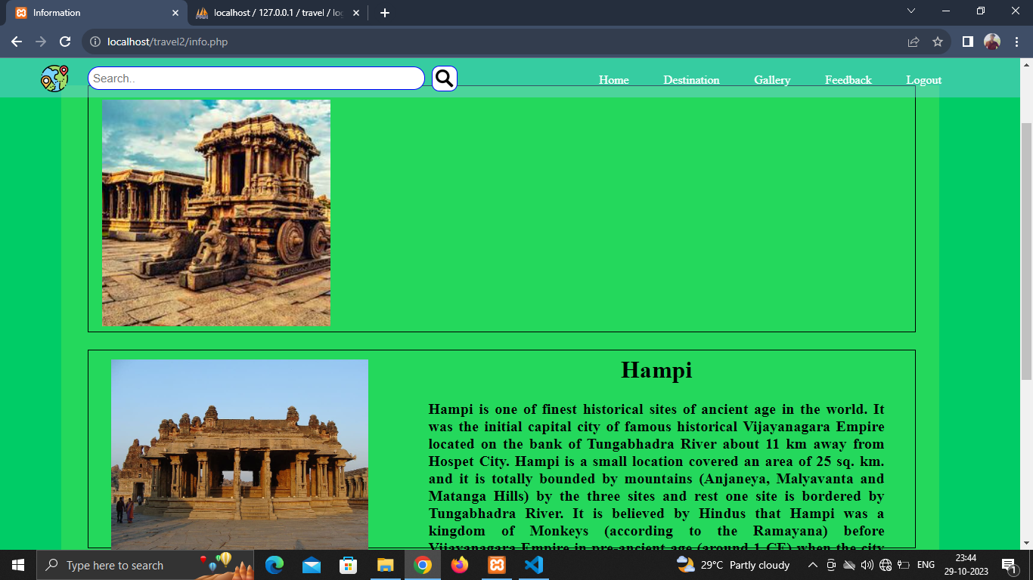

**Add personal story page:**

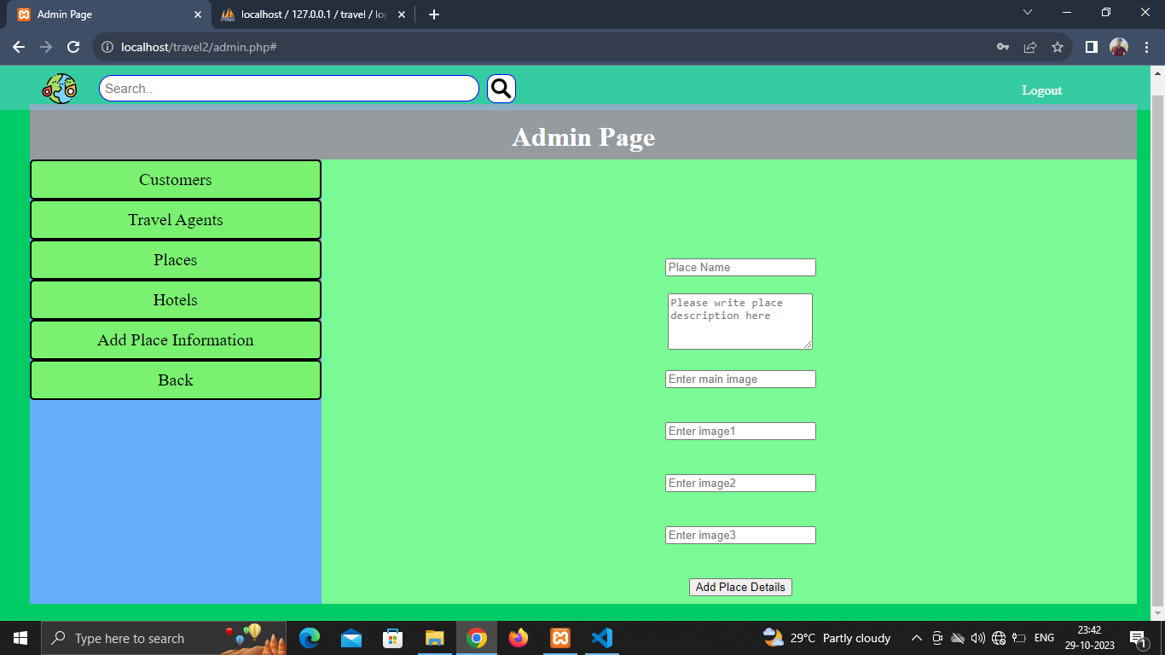

**Contact Page:**

